Part B circuits and outputs

Analog circuits Laboratory

1a. Precision Half Wave Rectifier

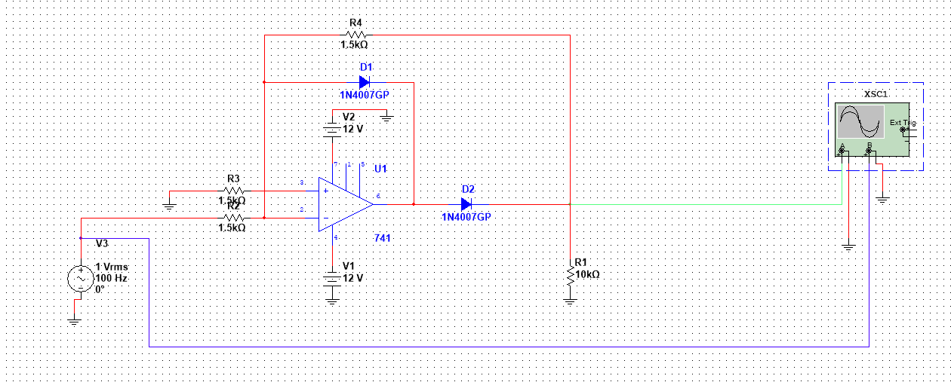

Output:

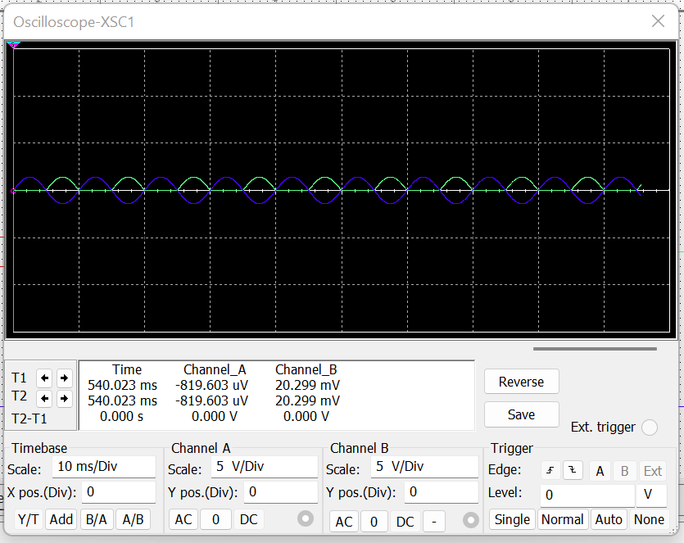

Blue coloured signal is input, Green coloured signal is output

b. Precision Full Wave Rectifier

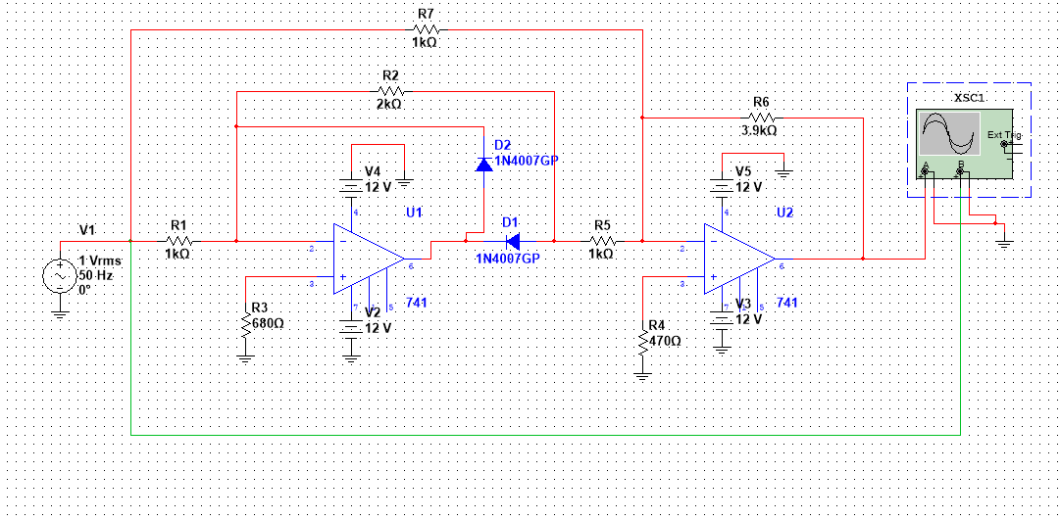

Output:

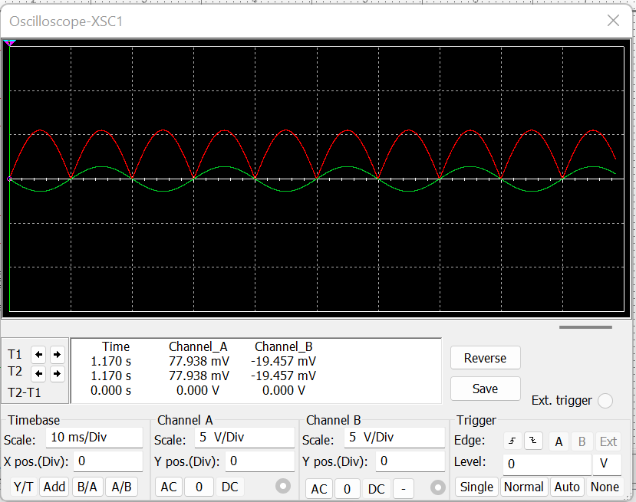

Green coloured signal is input, red coloured signal is output

2. RC phase shift oscillator and Hartley oscillator

a. RC phase shift oscillator

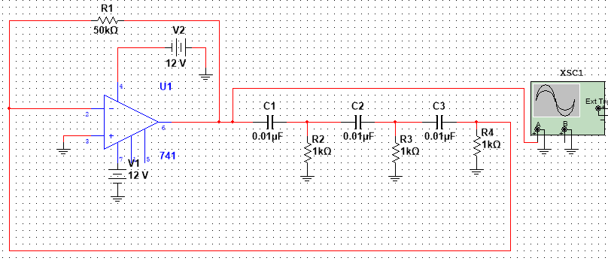

Output:

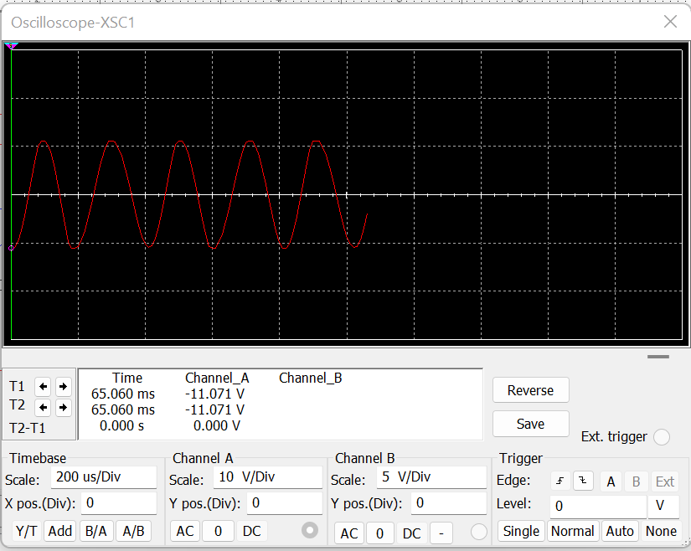

b. Hartley oscillator:

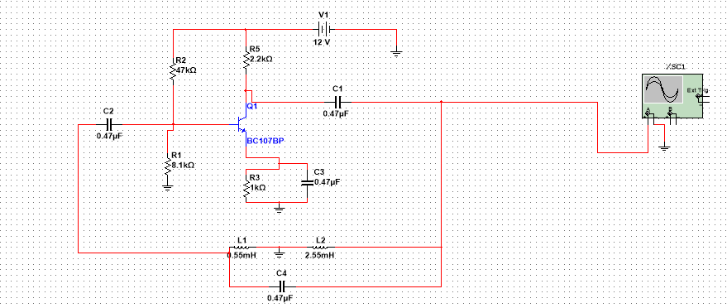

Output:

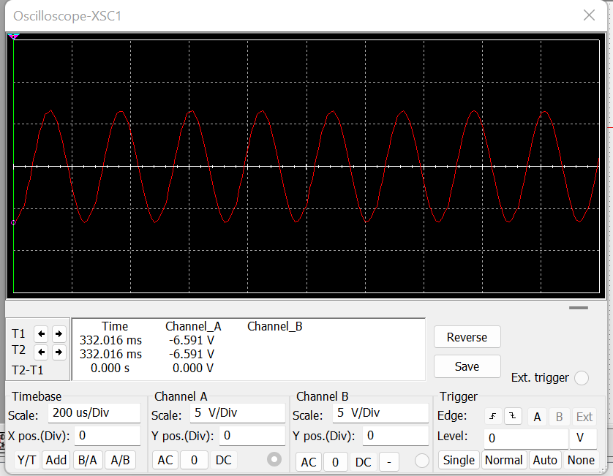

3.Narrow bandpass and band reject filters

a. Narrow bandpass filter

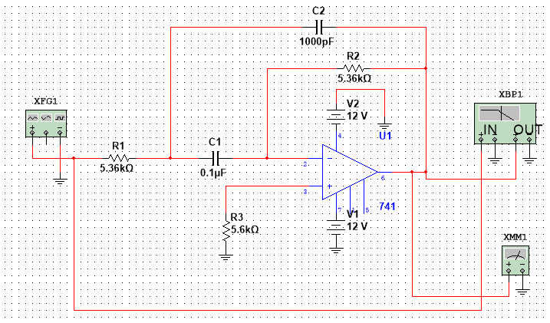

Output:

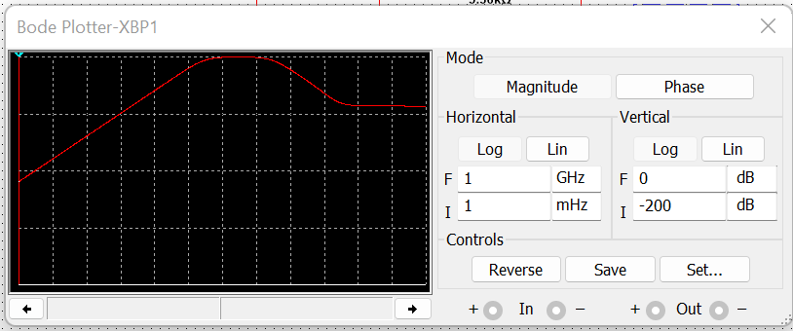

b. Narrow band reject filter:

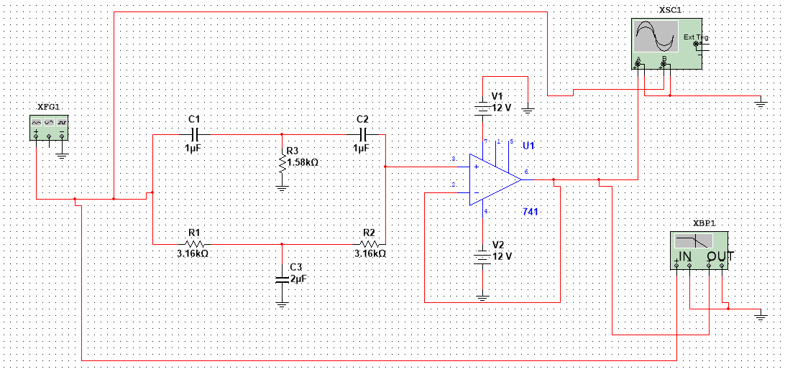

Output:

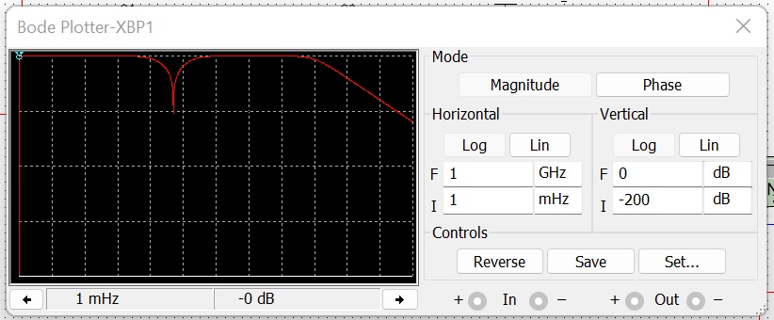

4.Monostable and Astable Multivibrator

a. Monostable multivibrator

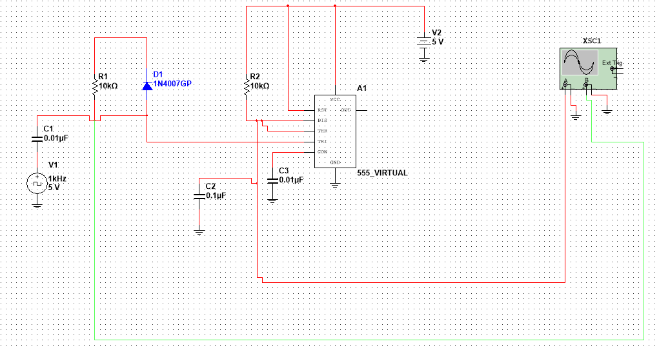

Output:

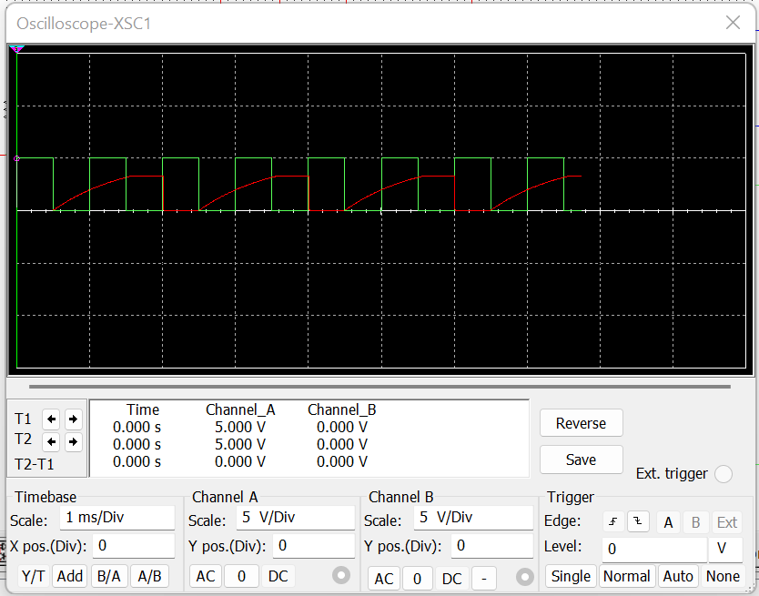

b. Astable Multivibrator

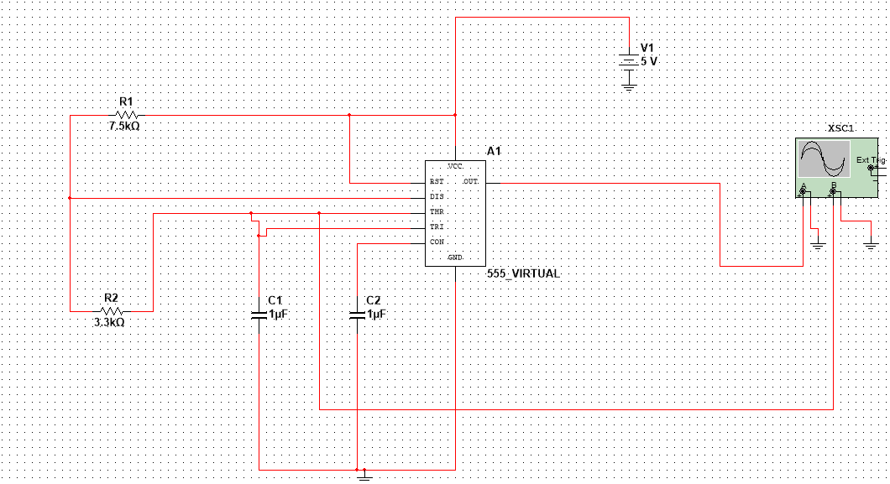

Output:

